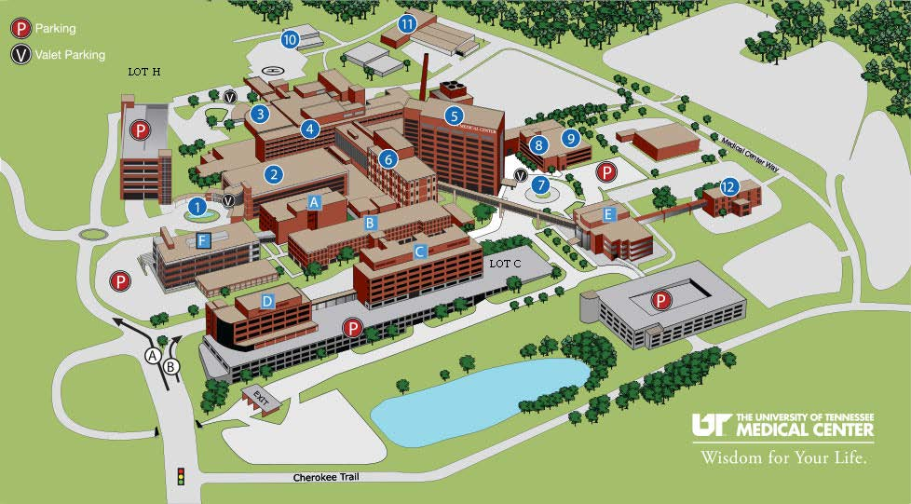

TO PARK: Traffic should be light and parking easily available. The most advantageous parking garage for our meeting at Morrison’s Conference and Education Center in Building 2 is Garage H (located in the upper left corner of the map under “Lot H”).
TO GET TO GARAGE H: From Alcoa Highway, follow route A on the map above to Garage H. There is no gate. When you leave there is a $2 charge.

TO MORRISON CENTER: From Garage H elevator tower, walk towards the main entrance of the hospital (Building 2 on the map). You will pass the Fountain Entrance (#1 on the map). Currently it is cordoned off for renovation. Nevertheless a walkway leads to the Building 2 entrance for easy access to the Morrison’s Center.
Once in the Building, walk straight towards the Registration Desk of the hospital. Once there turn right and walk towards the large opening at the end of the hall. Once you pass through the opening, a cafeteria will be on your left and the Morrison’s Center will be immediately on your right. Turn right and you are there!

