Appalachian Psychoanalytic Society
www.aps-tn.org

A Local Chapter of the Division of Psychoanalysis of the American Psychological Association

presents
the Paul Lerner Scholar’s Symposium
with

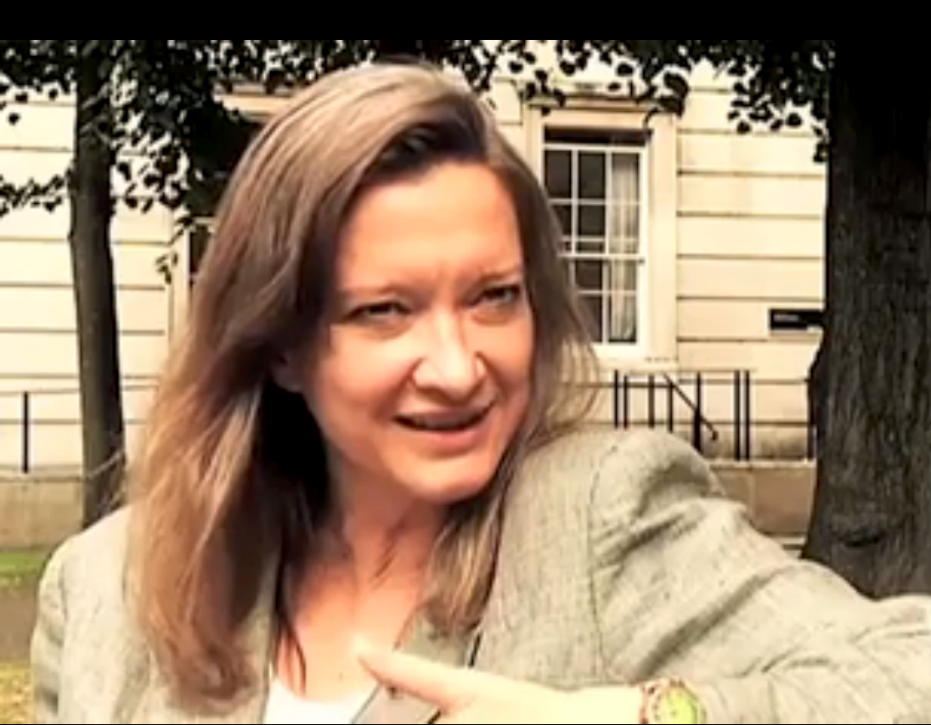
Deirdre Barrett, PhD
on

Trauma and Dreams

Saturday, May 16, 2015
8:30am-12:45pm

Fort Sanders Regional Medical Center
Classroom #5, Fifth Floor
1901 W. Clinch Avenue
Knoxville, TN 37919

Schedule
8:30am Registration
9:00am Membership Meeting
9:30am Presentation and Discussion
11:00am Break
11:15am Case Presentation (Scott Swan, PhD) and Discussion
12:45pm Complete Evaluations and Adjourn

Educational Objectives
After attending this introductory-level seminar in full, participants will be able to:
1. Describe at least three common effects of trauma on dream content in order to support accurate clinical conceptualizations when working with patients.
2. Distinguish and work with nightmares that are evolving and helpfully processing trauma as well as dreams that are re-traumatizing patients.
3. Design and implement therapeutic interventions to alter or interrupt repetitive post-traumatic nightmares.

Description of Program
This introductory program will examine common effects of trauma on dreams and nightmares as well as differences in dreams that correlate with children vs. adults, the nature of the trauma, and various cultural backgrounds. It will distinguish between dream phenomena common to people who are recovering well from their traumas vs. dream phenomena that affect people who have developed post-traumatic stress disorder or dissociative disorders. Dr. Barrett will discuss interventions to alter or interrupt repetitive post-traumatic nightmares. She will also respond to a case presentation by Dr. Scott Swan; audience participation will be welcomed.

Presenter
Deirdre Barrett, PhD (Clinical Psychology, University of Tennessee, Knoxville) is an assistant professor of psychology at Harvard Medical School. She is a Past President of the International Association for the Study of Dreams, Editor-in-Chief of the journal DREAMING, editor of the book Trauma and Dreams, and has lectured internationally on the topic.

Case Presenter
Scott Swan, PhD (Clinical Psychology) is a staff psychologist at the Veterans Health Administration, and an early career member of APS and Division 39. He trained at Northwestern University in Evanston, Illinois, and at the University of Tennessee, Knoxville. He currently teaches and supervises psychoanalytic psychotherapy at UT.
Participants
This program is open to all APS members and other interested mental health professionals who may not be members. It is not limited to individuals practicing in a predominately psychoanalytic mode. The material will be appropriate to introductory levels of practice and knowledge.

Registration Fees and Policies
This program is open only to Members (Professional, Scholar, ECP, and Student) and there is no fee to attend. Please register with an email to Diane Humphreys-Barlow at dhbaps@gmail so that APS can plan appropriately.
Non-members who join APS for the regular registration fee of $75 will be eligible to attend.

Facility is accessible to persons who are physically challenged. Reasonable accommodations will be made for persons requesting them.

American Psychological Association Approval Statement
Division 39 is approved by the American Psychological Association to sponsor continuing education for psychologists. Division 39 maintains responsibility for this program and its content.

Continuing Education
This program, when attended in its entirety, is available for 3.0 continuing education credits. With full attendance and completion of a program Evaluation and Learning Assessment, a certificate will be issued. Psychologists will have their participation registered through Division 39.

APS and Division 39 are committed to conducting all activities in conformity with the American Psychological Association’s Ethical Principles for Psychologists. APS and Division 39 are also committed to accessibility and non-discrimination in continuing education activities. Participants are asked to be aware of the need for privacy and confidentiality throughout the program. If program content becomes stressful, participants are encouraged to process these feelings during discussion periods. If participants have special needs, we will attempt to accommodate them. Please address requests, questions, concerns and any complaints to Jim Gorney, PhD, at 865­-694-0198.

There is no commercial support for this program nor are there any relationships between the CE Sponsor, presenting organization, program content, research, grants or other funding sources that could reasonably be construed as conflicts of interest. During the program, the validity/utility of the content and risks/limitations of the approaches discussed will be addressed.

Questions? Contact APS President Bill Hogan, MD, at wmh7@mindspring.com or 865-539-4000.

